**Complaint - No receipt of the A2P SMS authentication codes**

Help & Contact Us - Amazon Customer Service  
[OTP Issues - Amazon Customer Service](https://www.amazon.in/gp/help/customer/display.html?nodeId=GTNDYM87YMU7W9CV#GUID-D468FE38-F6A8-433A-9690-EA3EC6FA8A3C__SECTION_E97D3A0EA2174003898740DC47C38645)

Phone number: 1-206-577-1364 (International, charges may apply).

Email: feedback-amazon-app-android@amazon.com

Dear Support Team, please note that I'm unable to receive the SMS with the OTP code on my mobile number +994 XXXXXXXXXX. I have raised these issues with my mobile operator, but despite my attempts to resolve them, it appears that SMS messages from your service are not reaching their network.

Please troubleshoot and try rerouting SMS messages to correctly reach my mobile phone (over another SMS connectivity provider). Thank you!

For live chat please follow the steps:  
 **1.**Go to[Help & Contact Us - Amazon Customer Service](https://www.amazon.com/hz/contact-us/foresight/hubgateway-issues-10)

**Step1:**

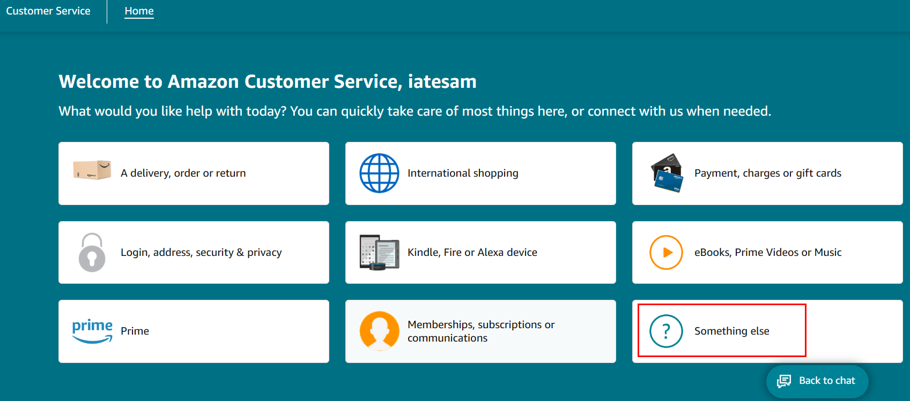

**Step2:**

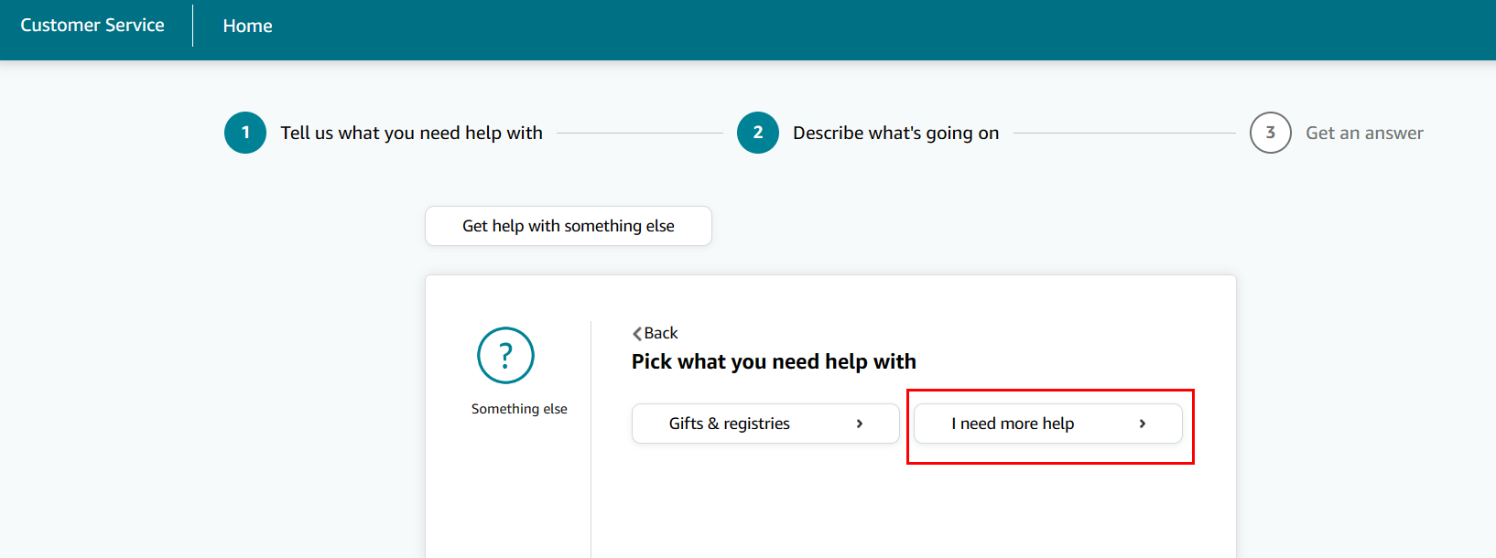

**Step3:**

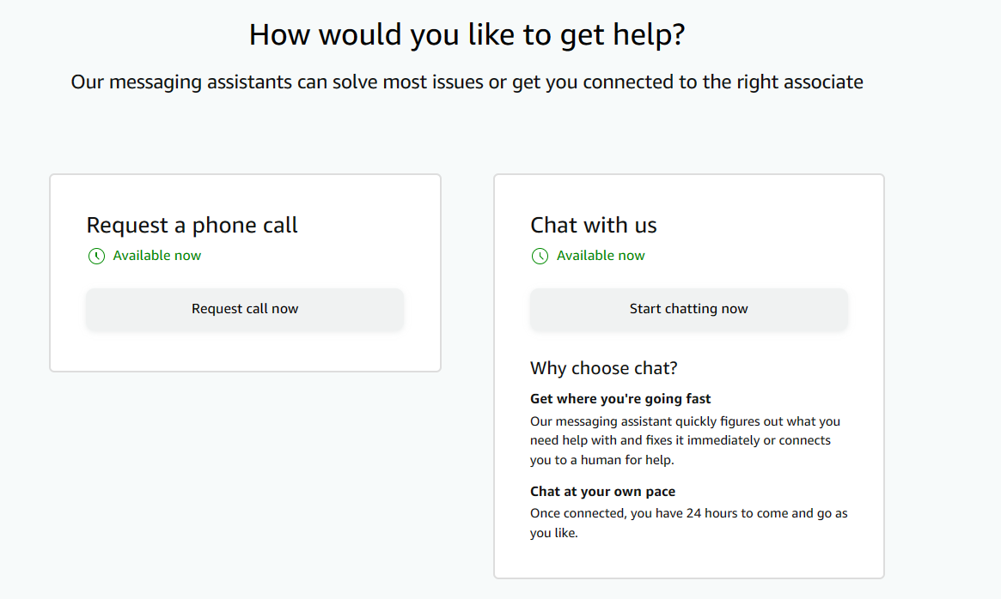

**2.** Chose contact **Message Centre** and **Ask the Amazon Assistant**

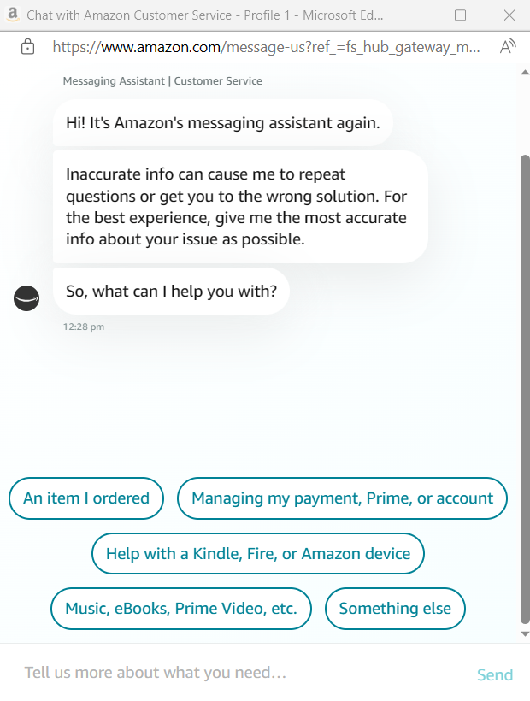

**Stating the issue at hand (inserting the text of the issue):**

Text:

Dear Support Team, please note that I'm unable to receive the SMS with the OTP code on my mobile number +994 XXXXXXXXXX. I have raised these issues with my mobile operator, but despite my attempts to resolve them, it appears that SMS messages from your service are not reaching their network.

Please troubleshoot and try rerouting SMS messages to correctly reach my mobile phone (over another SMS connectivity provider). Thank you!