Complaint - No receipt of the A2P SMS authentication codes

- Go to https://www.paypal.com/rs/smarthelp/contact-us and choose Message Us

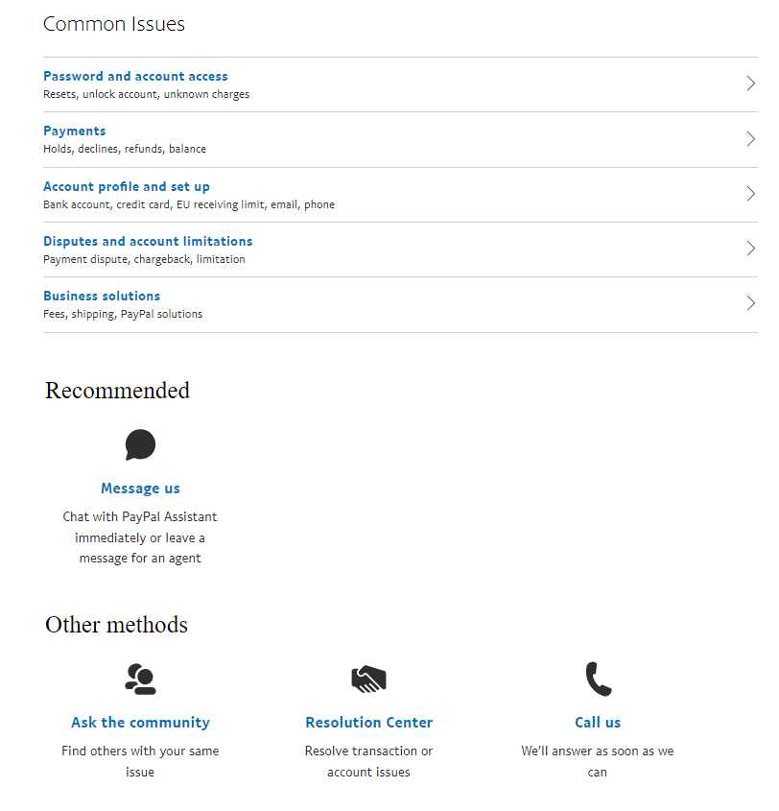

You can also send them an email at PayPal: app-feedback@paypal.com

Step 2: Choose a contact method and use the text below.

Text of the complaint (English):
Dear Support Team, please note that I'm unable to receive the SMS with the OTP code on my mobile number +994 XXXXXXXXXX. I have raised these issues with my mobile operator, but despite my attempts to resolve them, it appears that SMS messages from your service are not reaching their network.
Please troubleshoot and try rerouting SMS messages to correctly reach my mobile phone (over another SMS connectivity provider). Thank you!

